
(An Autonomous Institution, Affiliated to Anna University, Chennai)
MINI PROJECT
SALES DATA ANALYSIS AND VISUALIZATION USING
PYTHON, POWER BI, AND TABLEAU
Framework for Data Visual Analytics
SARVESWARAN B
241501506

ABSTRACT
Sales data analysis helps organizations understand customer demand, product performance, regional trends, and business profitability. This mini project demonstrates a practical workflow for analyzing sales records using Python, Power BI, and Tableau.
The main objective is to transform transaction-level data into meaningful business insights through data cleaning, descriptive analysis, and visual reporting. The dataset is examined using attributes such as order date, product category, region, quantity, sales value, cost, discount, and profit. Python with Pandas is used to inspect and prepare the data, while Matplotlib is used to create charts.
Power BI and Tableau are used to design interactive dashboards containing key performance indicators, category comparisons, monthly sales trends, regional sales shares, and profit summaries. Filters allow users to explore selected categories and regions and compare business performance from different perspectives.
The report uses an illustrative sample dataset to demonstrate the workflow; numerical findings shown in the charts are examples and should be recalculated when an organization's actual sales data is supplied. The project shows how data visualization can make sales information easier to interpret and support informed business decisions.
Keywords: Sales Analysis, Data Preprocessing, Python, Pandas, Power BI, Tableau, Dashboard, Profitability.

Project Objectives
- Inspect sales data and identify missing values, duplicates, and inconsistent data types.
- Calculate sales, cost, profit, units sold, and monthly performance indicators.
- Visualize sales performance by month, category, and region using suitable charts.
- Build dashboard layouts that present business KPIs and support data-driven decisions.

1. Data Preprocessing
Sales data was processed with Python and Pandas before visualization. The following steps demonstrate data inspection, duplicate checking, missing-value handling, and type conversion. The input file name is an example and should match the dataset used.

1.1 Loading and Inspecting the Data
import pandas as pd import numpy as np
df = pd.read_csv("sales_data.csv")
print(df.shape) print(df.info()) print(df.head()) print(df.describe())
The dataset is loaded into a DataFrame. Shape, information, sample rows, and descriptive statistics are checked to understand its structure and numerical ranges.

1.2 Missing Values and Duplicate Records
print(df.isnull().sum()) print("Duplicate rows:", df.duplicated().sum())
df = df.drop_duplicates()
num_cols = df.select_dtypes(include="number").columns for col in num_cols: df[col] = df[col].fillna(df[col].median())
cat_cols = df.select_dtypes(include="object").columns for col in cat_cols:
if not df[col].mode().empty: df[col] = df[col].fillna(df[col].mode()[0])
Duplicate rows are removed. Numerical missing values are filled with the median, while categorical missing values are filled with the most frequent category. These are example strategies; critical fields may require a different treatment.

1. Data Preprocessing (Continued)

1.3 Standardizing Text and Converting Dates
for col in df.select_dtypes(include="object").columns: df[col] = df[col].apply( lambda x: x.strip() if isinstance(x, str) else x )
if "Order_Date" in df.columns:
df["Order_Date"] = pd.to_datetime( df["Order_Date"], errors="coerce" ) df["Year"] = df["Order_Date"].dt.year df["Month_Number"] = df["Order_Date"].dt.month df["Month"] = df["Order_Date"].dt.month_name()
if {"Sales", "Cost"}.issubset(df.columns): df["Profit"] = df["Sales"] - df["Cost"]
Text fields are trimmed to remove unnecessary spaces. The order date is converted into a date format and year/month features are created for trend analysis. Profit can be calculated as sales minus cost when both columns are available.

1.4 Exporting the Cleaned Dataset
df.to_csv("Cleaned_Sales_Data.csv", index=False)
print("Cleaned dataset saved successfully") print("Final dataset shape:", df.shape) print(df.isnull().sum())
The cleaned dataset is exported for use in Python charts, Power BI, and Tableau. Column names in the code should match the actual dataset; the report's figures are generated from illustrative sample records.
Result: Sales data was inspected, cleaned, standardized, and prepared for visual analysis. This improves consistency and makes the dataset easier to explore.

2. Data Visualization Using Python
Charts were created using Pandas and Matplotlib to summarize sales performance. The example charts below use illustrative data and demonstrate the types of insights that can be extracted.
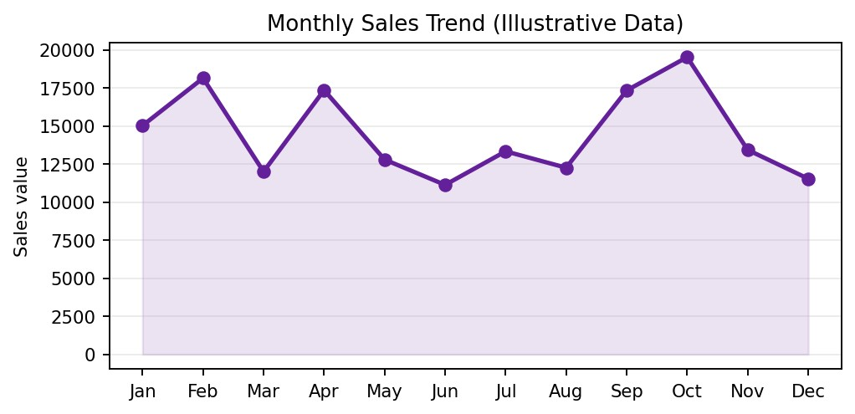
Figure 2.1: Monthly Sales Trend
Result: The line chart compares sales across calendar months. Peaks and dips can help identify seasonal demand, campaign effects, or periods that need further investigation.
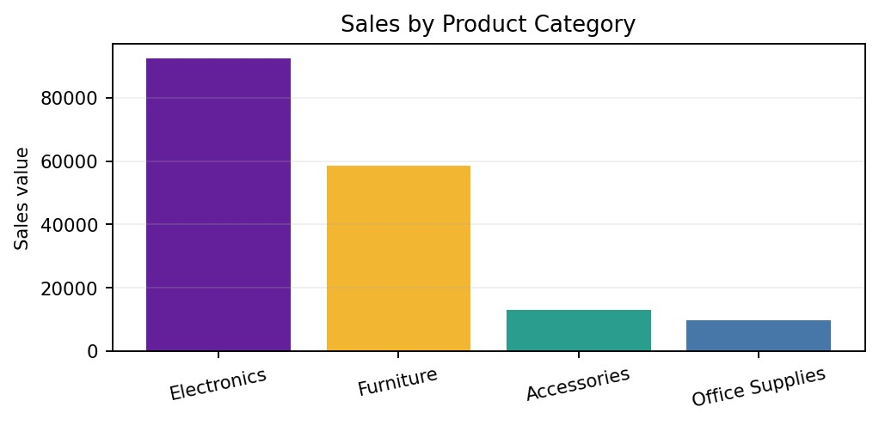
Figure 2.2: Sales by Product Category
Result: The category chart shows which product groups contribute more sales value and helps prioritize inventory and promotional analysis.

2. Data Visualization Using Python (Continued)
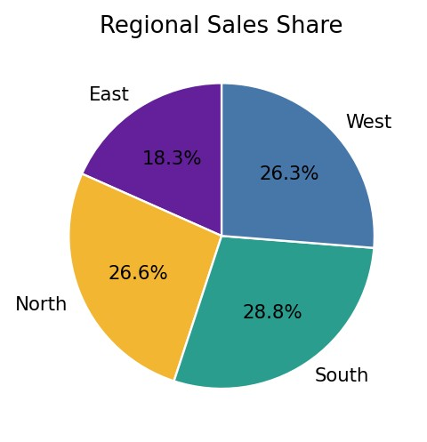
Figure 2.3: Regional Sales Share
Result: The pie chart compares each region's contribution to total sales. A balanced share may suggest broad reach, while a dominant region may warrant closer analysis.
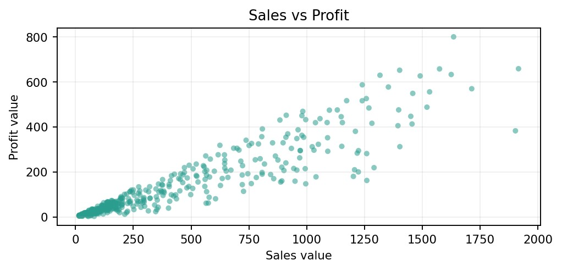
Figure 2.4: Sales vs Profit
Result: The scatter plot explores the relationship between sales value and profit. Outliers can highlight transactions with unusual discounts, costs, or margins.

2. Data Visualization Using Python (Continued)
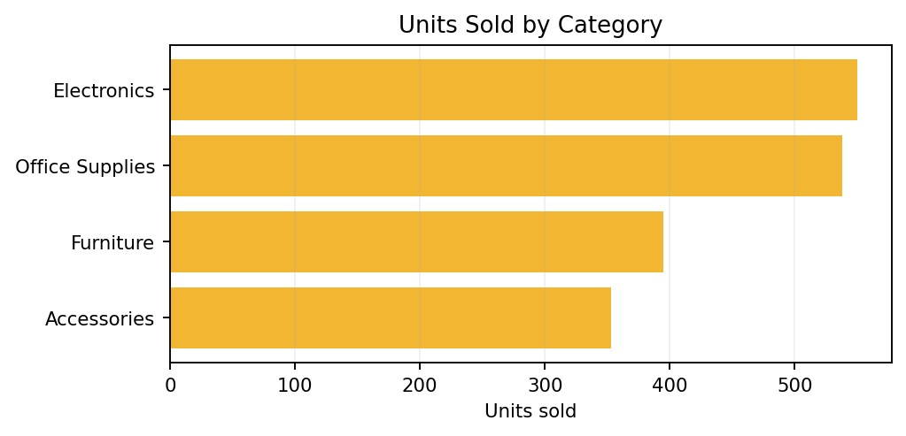
Figure 2.5: Units Sold by Category
Result: This chart compares sales volume by category. A category with many units sold but modest revenue may have a lower average selling price.
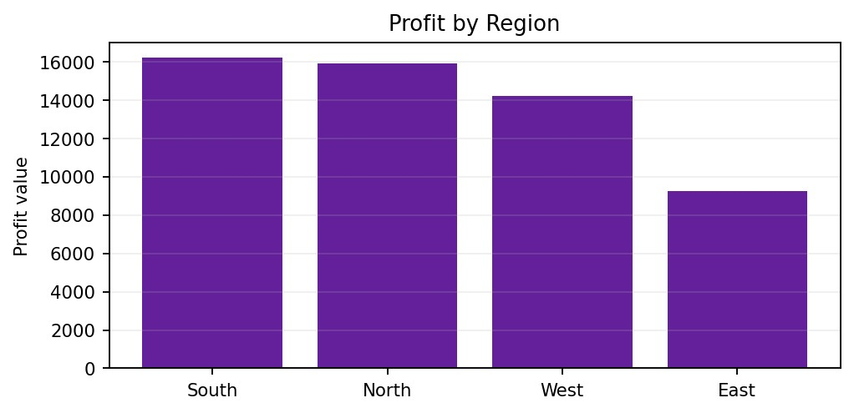
Figure 2.6: Profit by Region
Result: Regional profit comparison highlights where the business generates stronger returns. Profit should be considered alongside sales volume and operating costs.

3. Power BI Dashboard
Power BI can combine cleaned sales data, KPI cards, charts, and slicers into a single interactive report. The dashboard below is a report illustration; it is not a live Power BI file.
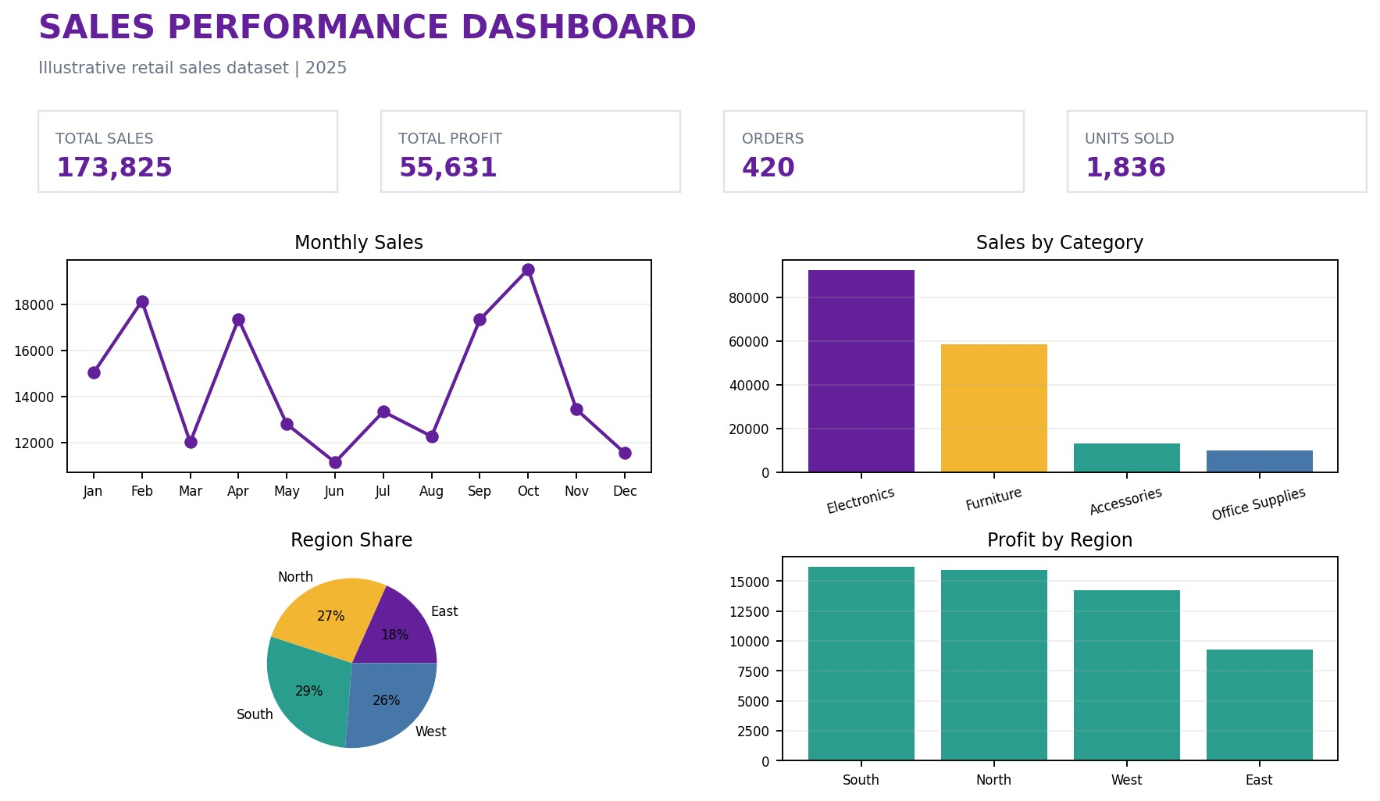
Figure 3.1: Sales Performance Dashboard in Power BI (Illustrative Layout)
- KPI Cards: Total Sales, Total Profit, Orders, and Units Sold provide a quick summary of performance.
- Slicers: Region, category, and order date can be used to filter the visuals when those fields are available.
- Charts: Monthly sales trend, category sales, regional share, and profit by region provide complementary views.
- Insights: Users can compare product groups, review changes over time, and investigate regional performance.

4. Tableau Dashboard
Tableau provides interactive visual analysis through worksheets, filters, and dashboards. The example below arranges regional profit, monthly sales, category sales, and sales share in a single view.
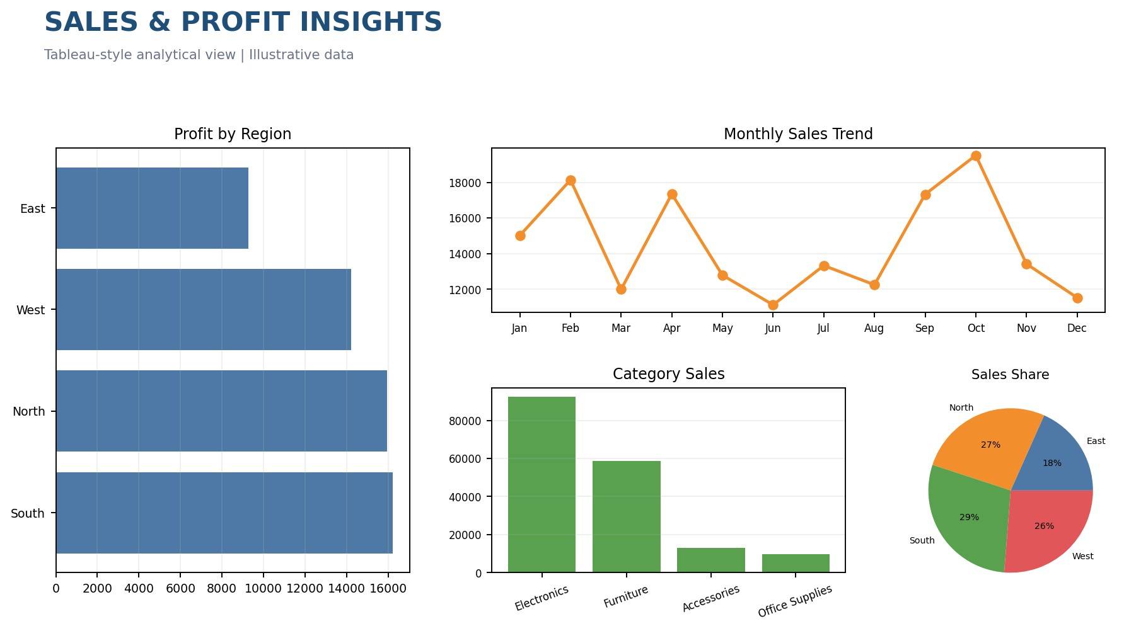
Figure 4.1: Sales and Profit Insights Dashboard in Tableau (Illustrative Layout)
- Filters: Region, product category, and order date help users focus on specific segments.
- Performance views: Monthly sales and category comparisons show how revenue changes over time and across products.
- Profitability: Regional profit comparisons add context beyond revenue alone.
- Exploration: Selecting a segment can help users investigate patterns and identify questions for further analysis.

5. Findings and Conclusion

5.1 Key Findings from the Demonstration
- Monthly sales charts make seasonal patterns and changes in demand easier to notice.
- Category comparisons show which product groups contribute more revenue and unit volume.
- Regional views compare sales share and profit, helping identify areas for deeper review.
- Sales and profit should be analyzed together because high revenue does not always mean high profitability.
- Interactive dashboards make it easier to filter data and communicate findings to different users.

5.2 Conclusion
This mini project demonstrates a complete workflow for sales data analysis and visualization using Python, Power BI, and Tableau. Python supports data inspection, cleaning, feature creation, and chart generation. Power BI and Tableau present the prepared information through dashboard-style visualizations that help users compare sales, units, and profit by time, product category, and region.
The charts in this report are based on illustrative sample data because no separate sales dataset was supplied. To produce organization-specific findings, replace the sample file with real sales records, verify the field names and business definitions, and refresh the charts and dashboards. The workflow can then support better reporting, inventory planning, and evidence-based business decisions.
Tools Used: Python, Pandas, NumPy, Matplotlib, Power BI, and Tableau.
End of Report

